**Renaming DMS Repository**

3a.01 Internal correspondence

Initial Preparation ETAS/ICO

|  |  |  |
| --- | --- | --- |
| **No.** | **Done** | **Item list** |
| **1** | ❑ | There must be an SMT ticket raised to rename an already existing repo in DMS Visual SVN Server. Generally the request is not very requested and is rare. |
| **2** | ❑ | Ensure that Repository name requested matches the SYNTAX/STANDARDS in accordance with the naming convention  The Repo name should start with <Development.| Quality.| Engineering.| Projects.|>  The Repo name should not contain any special symbols other than "_" and "."  The Repo name should be in format like <Department Name>.<Project_Name> |
| **3** | ❑ | Ensure that Visual SVN Server is up and running. |
| **4** | ❑ | Ensure that repository name should be available in DMS Visual SVN Repository |
| **5** | ❑ | Ensure that you have access to open, view to URL's like http://admin.ecn.etasgroup.com |
| **6** | ❑ | Ensure that you have access to open, view to URL's like https://inside-docupedia.bosch.com/confluence/display/ETAS/DMS |
| **7** | ❑ | Ensure that you have the administration access to DMS Visual SVN Prod Server |

**Renaming DMS Repository**

3a.01 Internal correspondence

Draft Checklist for Implementation ETAS/ICO

|  |  |  |  |
| --- | --- | --- | --- |
| **Step** | **Done** | **Item list** | **Step description** |
| **1** | ❑ | **Initial Preparation** compare red table | Refer to instructions in red table if all things required is available to proceed with renaming an existing repository in the DMS Visual SVN Repository.  Move the SMT ticket to your name and change the status to "In progress". |
| **2** |    | **Active Directory Configuration**  Renaming Active Directory | Active Directories used by this repo needs to be changed as per new naming convention and ensure these AD's are mapped to the renamed repo again. |
| **3** | ❑ | **Open Visual SVN Server**  **Manager** | Open the Visual SVN Server Manager. |
| **5** | ❑ | **Rename the folder**  Rename the folder with new name | Rename the repository with the new name as mentioned in the SMT Ticket. |
| **6** |  | **Visual SVN Server Restart**  Restart from the Manager | Restart by clicking on the restart button available in top left on the Visual SVN Server Manager. |
| **7** | ❑ | **Verify Server restarted**  Please ensure that service is restarted | Ensure that the service is restarted without any issues. If it fails, the please check for issues and resolve it. |
| **8** | ❑ | **Verification**  Success Criterions | Test, if you can access the Repo in Repo Browser, e.g. http://etasdms.de.bosch.com /svn/<Project Name> using your admin credentials. |
| **9** | ❑ | **Information about success** to whom it may concern | Inform the share responsible that repository was renamed. |

Page 2 of 4

**Active Directory Setup:**

1. Type mmc in windows search bar. This opens up a Console Root to open the Active Directory users and computers.
2. Add the Active Directory Snap In (Users,.. | IF not available install it via Windows Features, see picture.

Click on “Turn Windows features on or off”

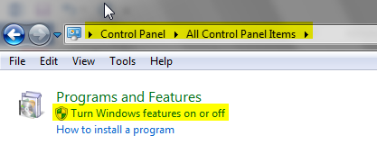

Turn On below marked features

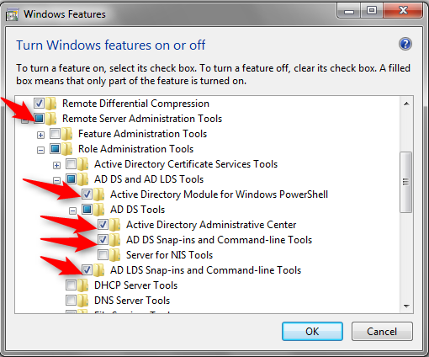

Now open mmc.exe and add the below features in Console root.

